VPrivCal Expert Review
  - Interface-aligned screening workbook for VPrivCal-Q10 and VPrivCal-Probe
Short workshop version for professional researchers
Decision / research question
Are the revised binary reminder questions, three-scene Probe interface, Hint walkthrough, and immediate cue-level acceptance evaluation sufficiently clear, actionable, low-burden, and safe for user cognitive interviews?

Method at a glance
Element | Current design
VPrivCal-Q10 | Ten direct reminder questions; Q1–Q6 share one binary response scale.
VPrivCal-Probe | Three egocentric scenes spanning private, public, and semi-public contexts. After a required Hint walkthrough, participants mark areas without naming categories, then review each present internal category through neutral linked-content labels and optional evidence highlights.
Calibration target | Provisional pilot target: approximately 5-7 minutes total for Q10 plus Probe. Time the required Hint walkthrough separately and confirm the total empirically.
Effectiveness test | Generic versus Q10-only versus full VPrivCal binary policies on manually verified held-out cue windows; participants rate immediate acceptance and state the preferred reminder decision.
Expert output | Keep/revise/remove decisions for Q10, Probe, Hint, stimuli, binary reminder rules, and cue-level acceptance measures; pilot-readiness vote.

Version 6.2 | July 2026 | Binary reminder and acceptance edition

1. Reviewer instructions
Complete ratings independently before discussion. Use the expert-review interface, start each scene from a fresh state, and judge the visible design as implemented. Proposed fixes belong in the comment fields and should not inflate the current rating. The profile screen is currently disabled and is not participant-facing functionality.
Rating | Meaning
1 | Major problem / not ready
2 | Substantial revision needed
3 | Acceptable with minor revision
4 | Strong / ready for cognitive testing

2. Method workflow
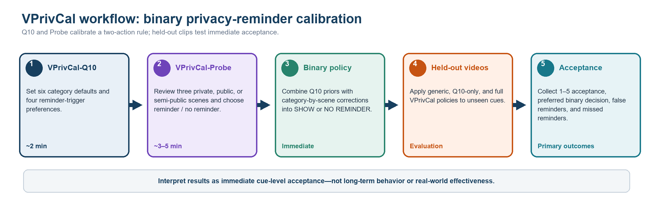
Review question | Rating / comment
Does the live workflow make clear that Q10 and Probe are two components of one method while the profile screen remains disabled? | 1 2 3 4 Comment: ______________________________
Is the 5-7 minute target credible when the required Hint walkthrough and category-complete review are included and timed separately? | 1 2 3 4 Comment: ______________________________
Is it clear that simulated rule pre-verification and held-out cue-level acceptance testing occur after elicitation, not during the Probe? | 1 2 3 4 Comment: ______________________________

3. VPrivCal-Q10 candidate questions
Shared binary reminder scale for Q1–Q6
1 Do not show a privacy reminder | 2 Show a brief privacy reminder

Item | Category / policy dimension | Relevance | Clarity | Actionability | Predictive value | Decision
Q1 | Biometric data | 1 2 3 4 | 1 2 3 4 | 1 2 3 4 | 1 2 3 4 | Keep / Revise / Remove
Q2 | Children images | 1 2 3 4 | 1 2 3 4 | 1 2 3 4 | 1 2 3 4 | Keep / Revise / Remove
Q3 | Personally identifiable information (PII) | 1 2 3 4 | 1 2 3 4 | 1 2 3 4 | 1 2 3 4 | Keep / Revise / Remove
Q4 | Legal sensitivity information | 1 2 3 4 | 1 2 3 4 | 1 2 3 4 | 1 2 3 4 | Keep / Revise / Remove
Q5 | Personal life | 1 2 3 4 | 1 2 3 4 | 1 2 3 4 | 1 2 3 4 | Keep / Revise / Remove
Q6 | Background individuals | 1 2 3 4 | 1 2 3 4 | 1 2 3 4 | 1 2 3 4 | Keep / Revise / Remove
Q7 | Inferred privacy risks | 1 2 3 4 | 1 2 3 4 | 1 2 3 4 | 1 2 3 4 | Keep / Revise / Remove
Q8 | Reminder sensitivity | 1 2 3 4 | 1 2 3 4 | 1 2 3 4 | 1 2 3 4 | Keep / Revise / Remove
Q9 | Uncertain detections | 1 2 3 4 | 1 2 3 4 | 1 2 3 4 | 1 2 3 4 | Keep / Revise / Remove
Q10 | Task-irrelevant sensitive information | 1 2 3 4 | 1 2 3 4 | 1 2 3 4 | 1 2 3 4 | Keep / Revise / Remove

4. Item-specific prompts
Q1. Biometric data
Faces, fingerprints, and other distinctive body features that may identify a person.
Main concern / suggested wording: ______________________________________________________________
Q2. Children images
Children, school events, playgrounds, and child-related activities.
Main concern / suggested wording: ______________________________________________________________
Q3. Personally identifiable information (PII)
Financial or medical data; names, passports, email addresses, phone numbers, GPS, license plates, and other identifiers.
Main concern / suggested wording: ______________________________________________________________
Q4. Legal sensitivity information
Nudity or explicit imagery; violent or unlawful acts; criminal acts; weapons or other high-risk items.
Main concern / suggested wording: ______________________________________________________________
Q5. Personal life
Home interiors, personal items, location context, landmarks, routines, relationships, and activities.
Main concern / suggested wording: ______________________________________________________________
Q6. Background individuals
Passersby, bystanders, coworkers, patients, patrons, and other people incidentally captured.
Main concern / suggested wording: ______________________________________________________________
Q7. Inferred privacy risks
When a visual cue supports a sensitive inference, should the assistant show a brief privacy reminder?
Main concern / suggested wording: ______________________________________________________________
Q8. Reminder sensitivity
How broad should the trigger be when a rule otherwise calls for a reminder: only the most likely or serious cues, or any plausible cue?
Main concern / suggested wording: ______________________________________________________________
Q9. Uncertain detections
When the assistant is unsure whether a cue is privacy-sensitive, should it show a brief privacy reminder?
Main concern / suggested wording: ______________________________________________________________
Q10. Task-irrelevant sensitive information
When privacy-sensitive content is visible but not needed for the current task, should the assistant show a brief privacy reminder?
Main concern / suggested wording: ______________________________________________________________

5. VPrivCal-Probe stimuli
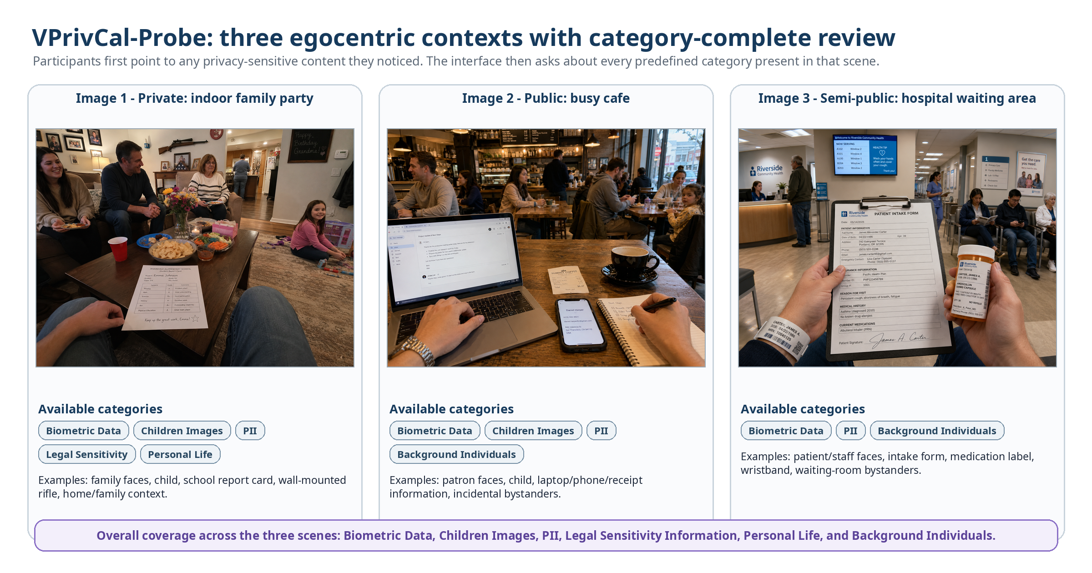
Two questions per internal category-scene pair
A. Before the highlight: already aware / noticed but did not consider privacy / did not notice or realize VLM capability / not a concern.
B. Reminder decision for similar content: do not show a privacy reminder / show a brief privacy reminder.
Category identities are hidden; participants see neutral linked-content labels.
The stimuli span private, public, and semi-public contexts. Coverage remains scene-level and internally category-complete across all six high-level categories. Phase A is unprompted pointing; Phase B uses neutral linked-content labels because participant-facing category identities are hidden.
Criterion | Scene 1 | Scene 2 | Scene 3 | Comment
Context is realistic and distinct | 1 2 3 4 | 1 2 3 4 | 1 2 3 4 | ________________
Internal category coverage is complete for the scene | 1 2 3 4 | 1 2 3 4 | 1 2 3 4 | ________________
The optional evidence highlight is correctly localized and understandable | 1 2 3 4 | 1 2 3 4 | 1 2 3 4 | ________________
The scene includes both obvious and subtle privacy content | 1 2 3 4 | 1 2 3 4 | 1 2 3 4 | ________________
Point-first marking and neutral linked-content review are usable | 1 2 3 4 | 1 2 3 4 | 1 2 3 4 | ________________
Cultural and ethical risk is acceptable | 1 2 3 4 | 1 2 3 4 | 1 2 3 4 | ________________
Implemented sequence: require the five-step Hint before the first scene (practice data are not saved; Hint time is separate). Phase A shows a clean image: participants place/delete points or confirm none; category/detection matching is internal, unmatched points are retained, and only ambiguous overlaps trigger a neutral chooser. Phase B reviews every present internal category sequentially with neutral linked-content labels, an optional Show/Hide highlight, awareness status, and binary reminder preference. Category identities remain hidden.

6. Probe-level review
Review question | Rating | Comment
Does the required five-step Hint teach point, delete, phase transition, response layout, and next-item navigation without contaminating real answers? | 1 2 3 4 | ________________________
Is it clear that Hint data are not saved and Hint time is excluded from Probe completion time? | 1 2 3 4 | ________________________
Does Phase A preserve an interpretable unprompted signal when categories and detections remain hidden and unmatched points are retained? | 1 2 3 4 | ________________________
Are neutral linked-content labels plus the Show/Hide highlight sufficient to identify the review target without category names? | 1 2 3 4 | ________________________
Do the awareness-status and binary reminder-preference items remain valid and sufficiently brief across every present internal category? | 1 2 3 4 | ________________________
Are pointer/delete, overlap chooser, move/zoom/pan/reset, keyboard controls, and list fallback sufficiently usable and accessible? | 1 2 3 4 | ________________________

7. Held-out evaluation review
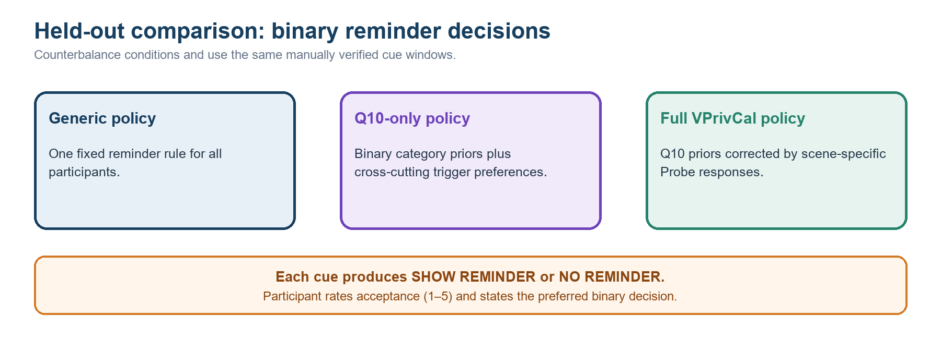
Metric / design decision | Expert judgment
Primary outcome: immediate acceptance rating (1–5) after each held-out cue decision | Strong / Revise / Reject
Binary reminder-decision alignment | Strong / Revise / Reject
False-reminder and missed-reminder rates | Strong / Revise / Reject
Separate detector validity from privacy relevance and reminder acceptance | Strong / Revise / Reject
Use short, manually verified held-out windows with emerging cues; do not claim long-term behavior or effectiveness | Strong / Revise / Reject
Simulate binary rule outputs before the pilot; label them non-empirical and keep them separate from participant acceptance evidence | Strong / Revise / Reject

8. Final decision
VPrivCal-Q10: □ Proceed □ Minor revision □ Major revision □ Replace
VPrivCal-Probe interface (including Hint): □ Proceed □ Minor revision □ Major revision □ Replace
Workflow and immediate acceptance evaluation: □ Proceed □ Minor revision □ Major revision □ Replace
Simulated policy-output pre-verification: □ Proceed □ Minor revision □ Major revision □ Defer
Overall readiness for cognitive interviews: □ Yes □ Yes after revision □ No
Three highest-priority changes:
1. __________________________________________________________________________________
2. __________________________________________________________________________________
3. __________________________________________________________________________________
Alternative idea or missing test: ______________________________________________________________________

